Supporting Information
Rec. Nat. Prod. X:X (202X) XX-XX

2-Bisabolen-1,10,11,12-tetraol, A New Bisabolane Sesquiterpene from Marine Alga-Sourced Aspergillus taichungensis 299 and Its Antibacterial Activity against Common Pediatric Pathogens

Lianlian Ji ¹, Xiu Weng ¹, Zhishu Li ¹, Guan-Yi Cao ^{2,*} , Minli Pan ^{1,}*

¹ Department of Pediatrics, The Third Affiliated Hospital of Wenzhou Medical University, Ruian 325200, China
² Department of General Surgery, Suqian First Hospital, Suqian 223899, China

Table of Contents | Page
Figure S1: HR-ESI-MS spectrum of 1 | 2
Figure S2: ¹H-NMR (500 MHz, CD₃OD) spectrum of 1  Figure S3: Enlarged ¹H-NMR (500 MHz, CD₃OD) spectrum of 1 | 3  3
Figure S4: ¹³C-NMR and DEPT (125 MHz, CD₃OD) spectra of 1 | 4
Figure S5: HSQC spectrum of 1  Figure S6: Enlarged HSQC spectrum of 1 | 5  6
Figure S7: Enlarged HSQC spectrum of 1 | 7
Figure S8: HMBC spectrum of 1 | 8
Figure S9: Enlarged HMBC spectrum of 1 | 9
Figure S10: Enlarged HMBC spectrum of 1 | 10
Figure S11: ¹H-¹H COSY spectrum of 1 | 11
Figure S12: Enlarged ¹H-¹H COSY spectrum of 1 | 12
Figure S13: Enlarged ¹H-¹H COSY spectrum of 1 | 13
Figure S14: NOESY spectrum of 1 | 14
Figure S15: Enlarged NOESY spectrum of 1 | 15
Figure S16: Scifinder search results of 1 | 16
Table S1: ¹³C NMR data of 1 and alcohol 14 | 17
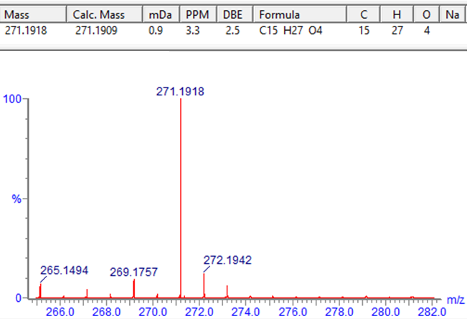
Figure S1: HR-ESI-MS spectrum of 1
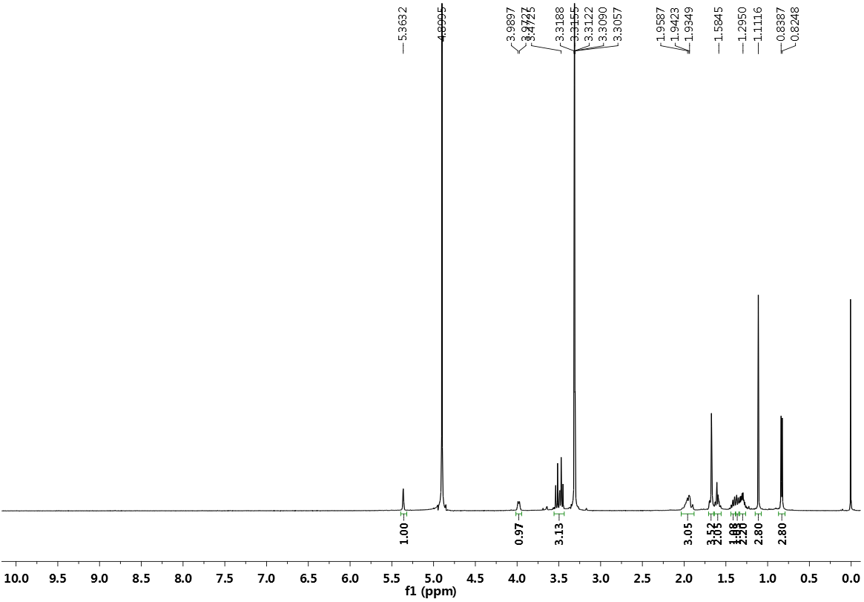
Figure S2: ¹H-NMR (500 MHz, CD₃OD) spectrum of 1
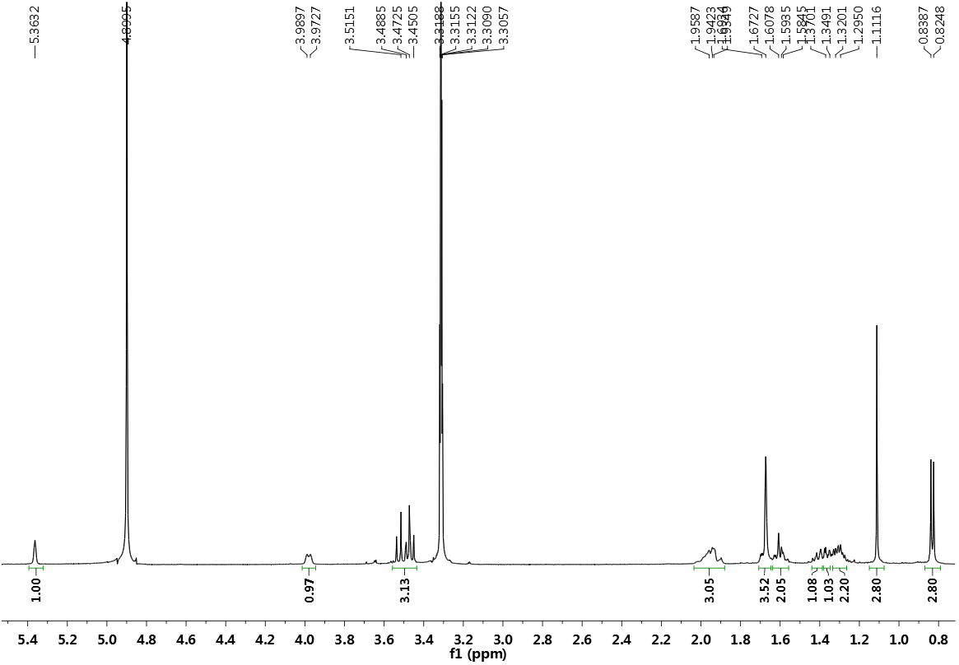
Figure S3: Enlarged ¹H-NMR (500 MHz, CD₃OD) spectrum of 1
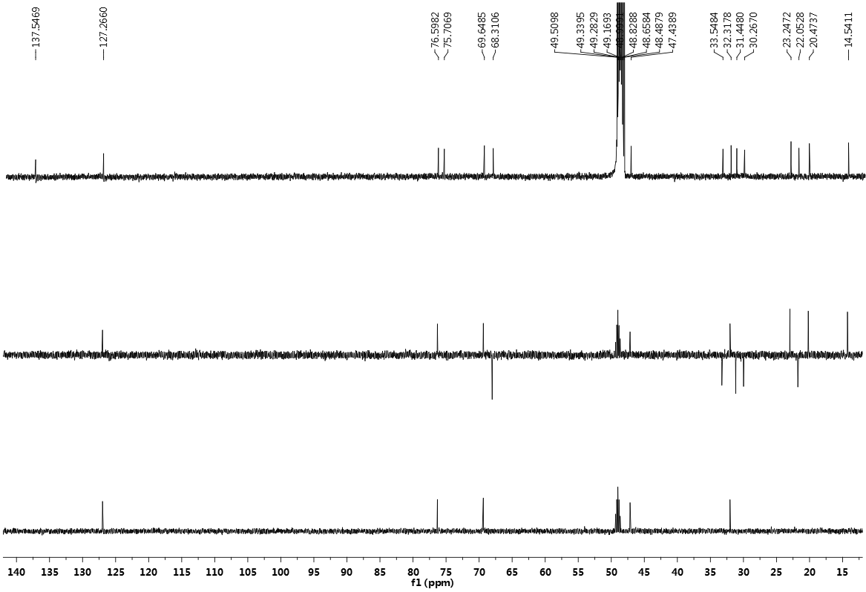
Figure S4: ¹³C-NMR and DEPT (125 MHz, CD₃OD) spectra of 1
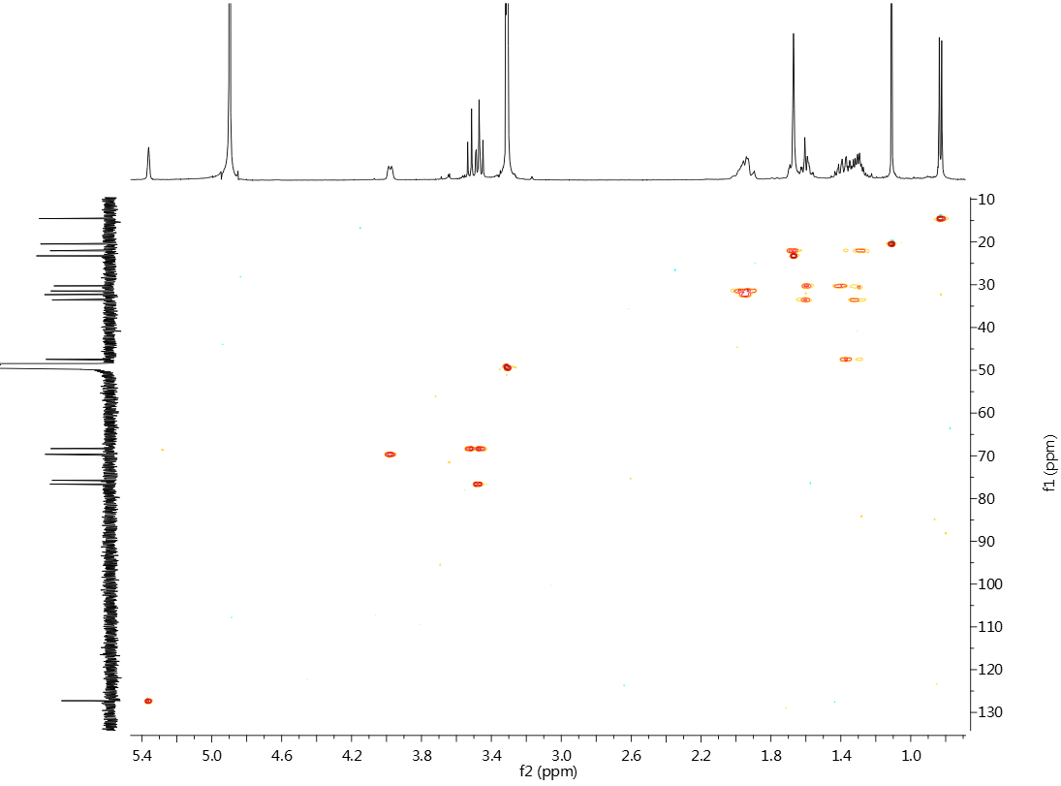
Figure S5: HSQC spectrum of 1
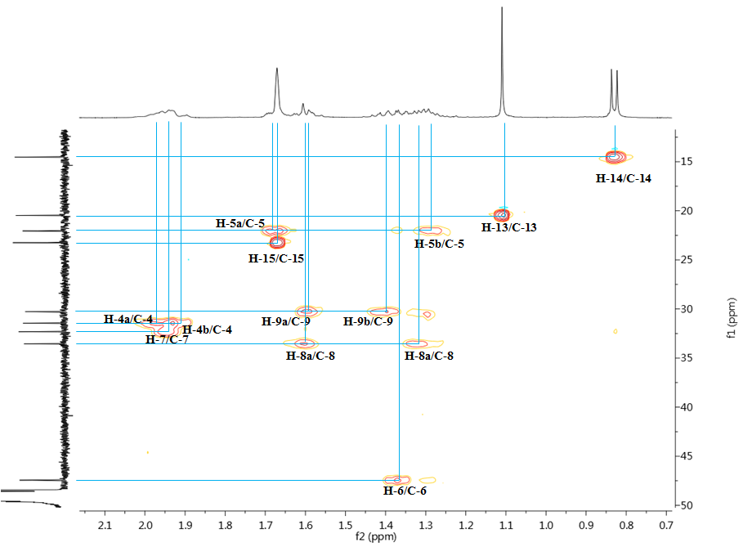
Figure S6: Enlarged HSQC spectrum of 1
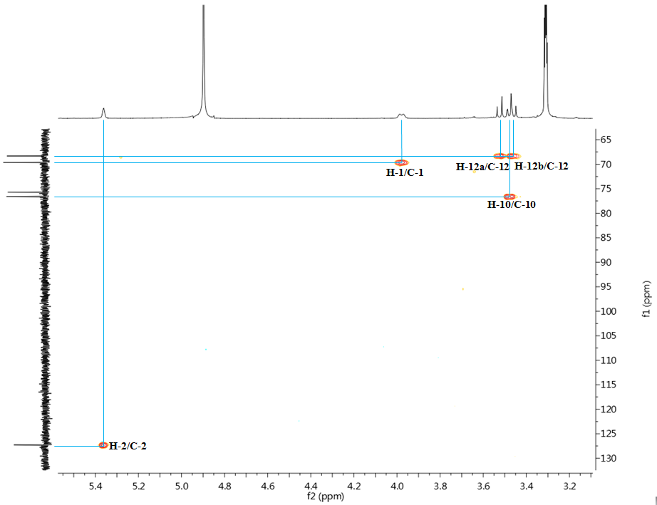
Figure S7: Enlarged HSQC spectrum of 1
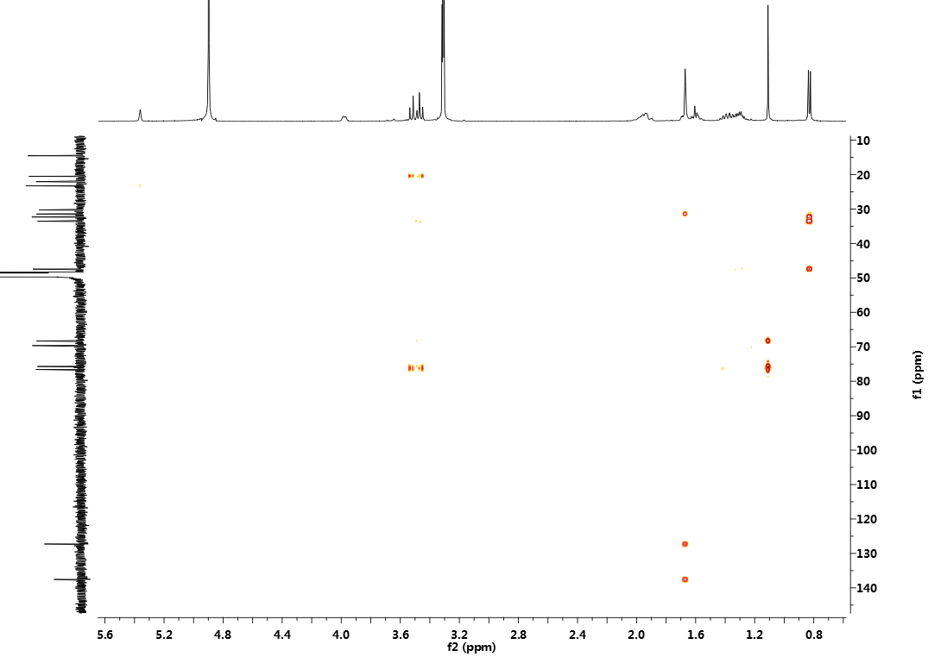
Figure S8: HMBC spectrum of 1
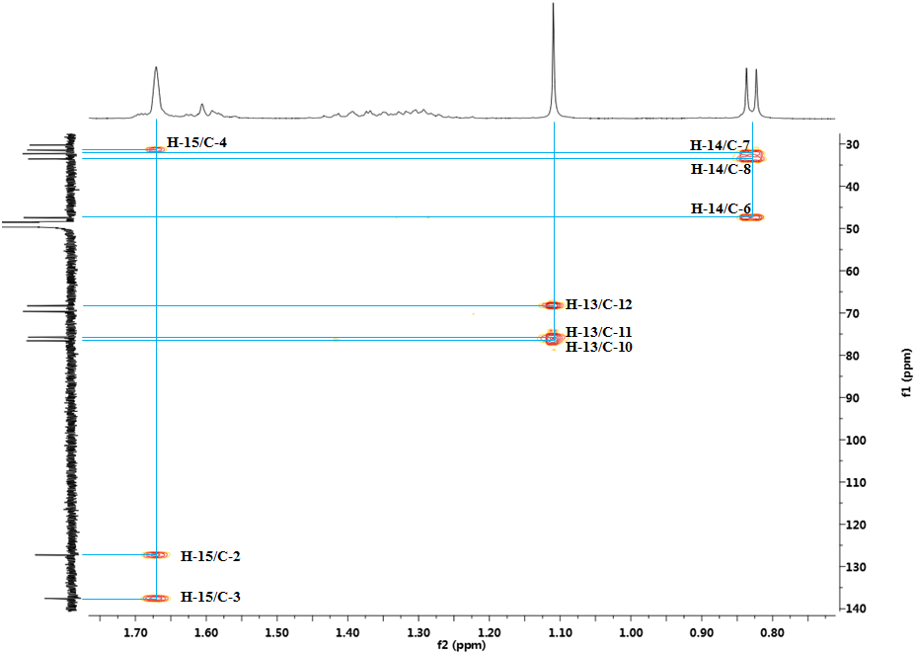
Figure S9: Enlarged HMBC spectrum of 1

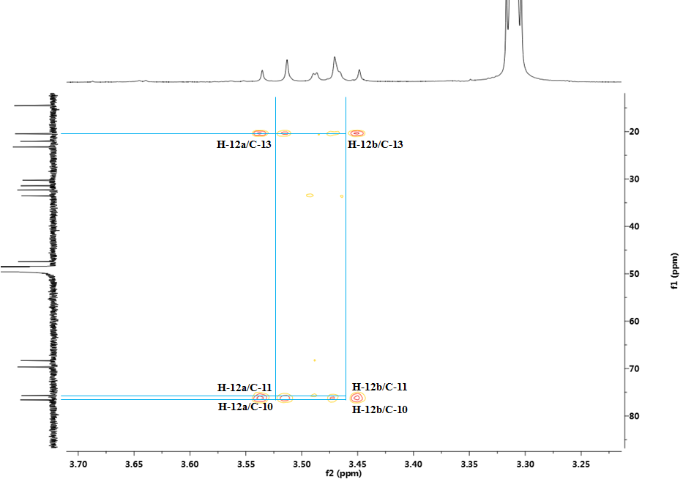
Figure S10: Enlarged HMBC spectrum of 1

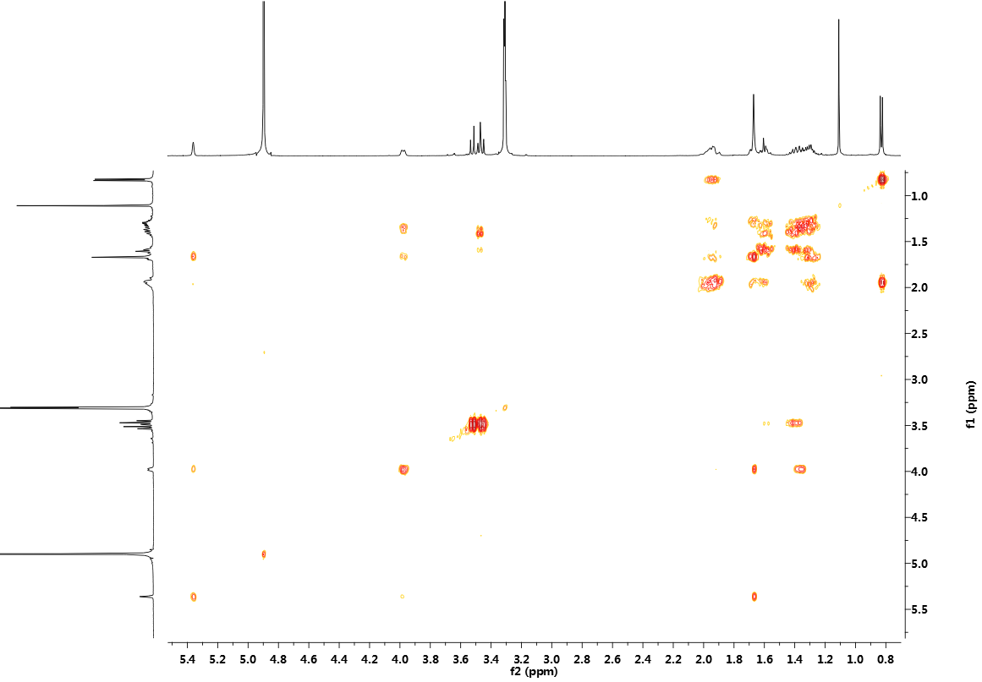
Figure S11: ¹H-¹H COSY spectrum of 1
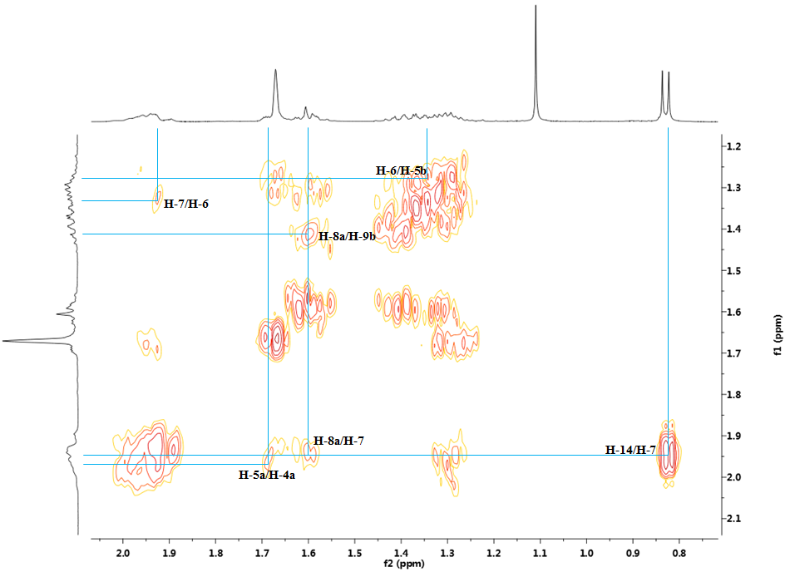
Figure S12: Enlarged ¹H-¹H COSY spectrum of 1
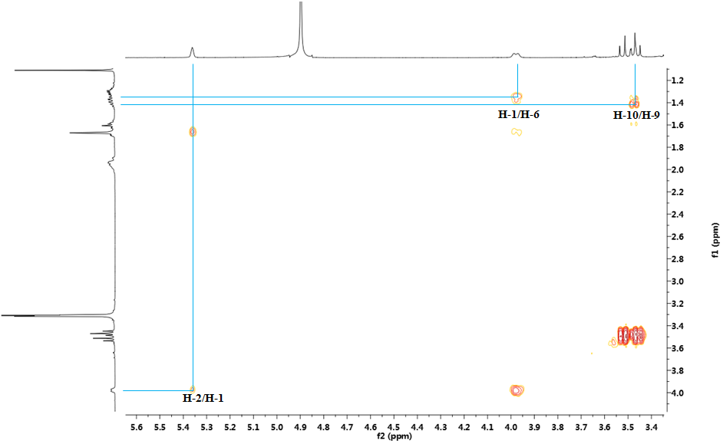
Figure S13: Enlarged ¹H-¹H COSY spectrum of 1

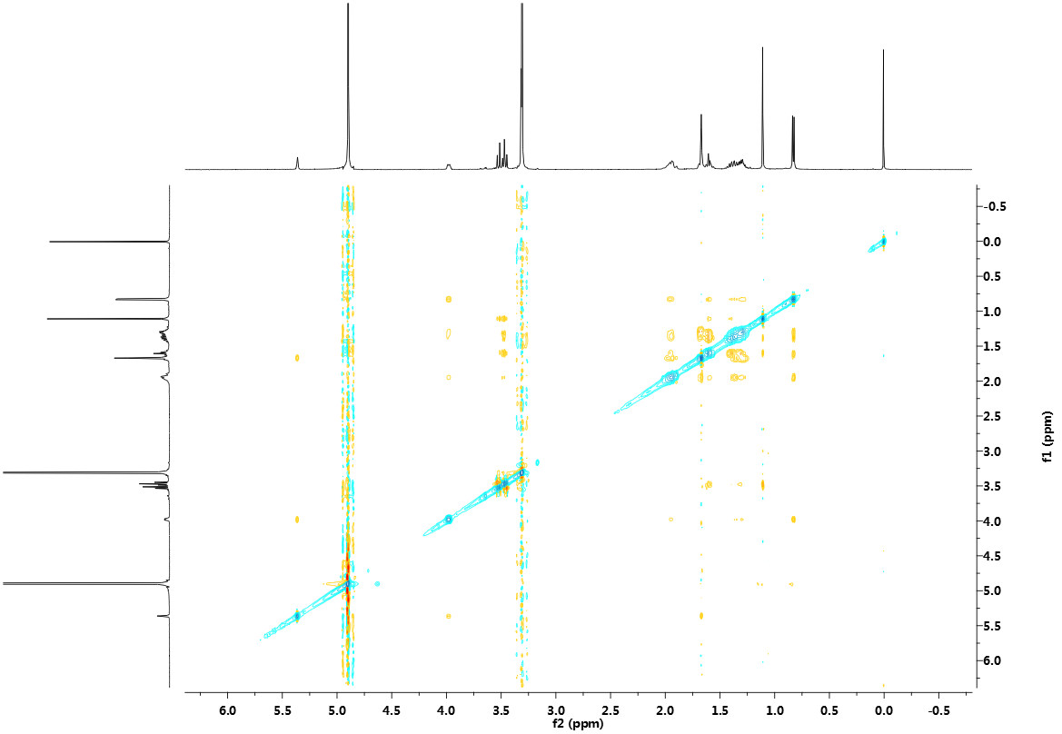
Figure S14: NOESY spectrum of 1
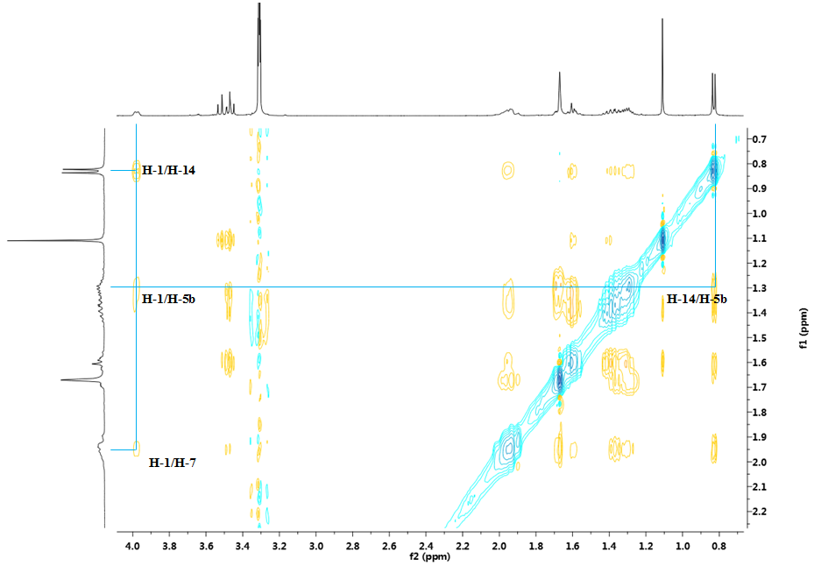
Figure S15: Enlarged NOESY spectrum of 1

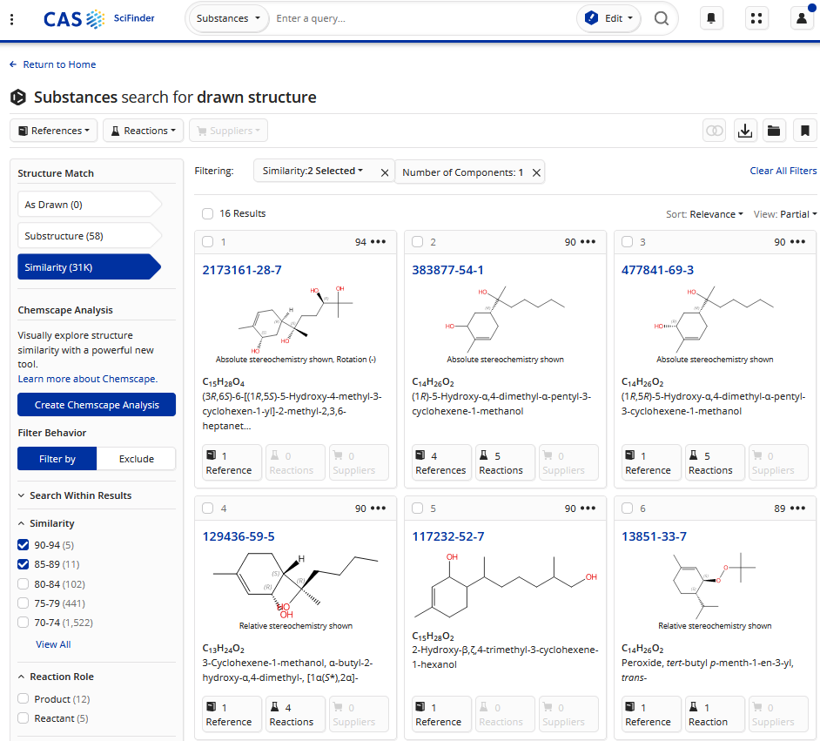
Figure S16: Scifinder search results of 1
Table S1: ¹³C NMR data of compound 1 and alcohol 14
No | 1 |  | alcohol 14 [12]
1 | 69.6, CH |  | 69.4, CH
2 | 127.3, CH |  | 125.0, CH
3 | 137.5, C |  | 137.6, C
4 | 31.4, CH₂ |  | 30.7, CH₂
5 | 22.1, CH₂ |  | 21.1, CH₂
6 | 47.4, CH |  | 46.7, CH
7 | 32.3, CH |  | 31.2, CH
8 | 33.5, CH₂ |  | 35.7, CH₂
9 | 30.3, CH₂ |  | 25.9, CH₂
10 | 76.6, CH |  | 125.5, CH
11 | 75.7, C |  | 131.4, C
12 | 68.3, CH₂ |  | 26.4, CH₃
13 | 20.5, CH₃ |  | 17.9, CH₃
14 | 14.5, CH₃ |  | 14.6, CH₃
15 | 23.2, CH₃ |  | 23.3, CH₃

*Corresponding authors: E-mails: caoguanyi2024@163.com (G.-Y. Cao); panminli0403@126.com (M. Pan)

